Name: 江才文 Student ID: 2019233157

1. Hessian in Logistic Regression (10 points)

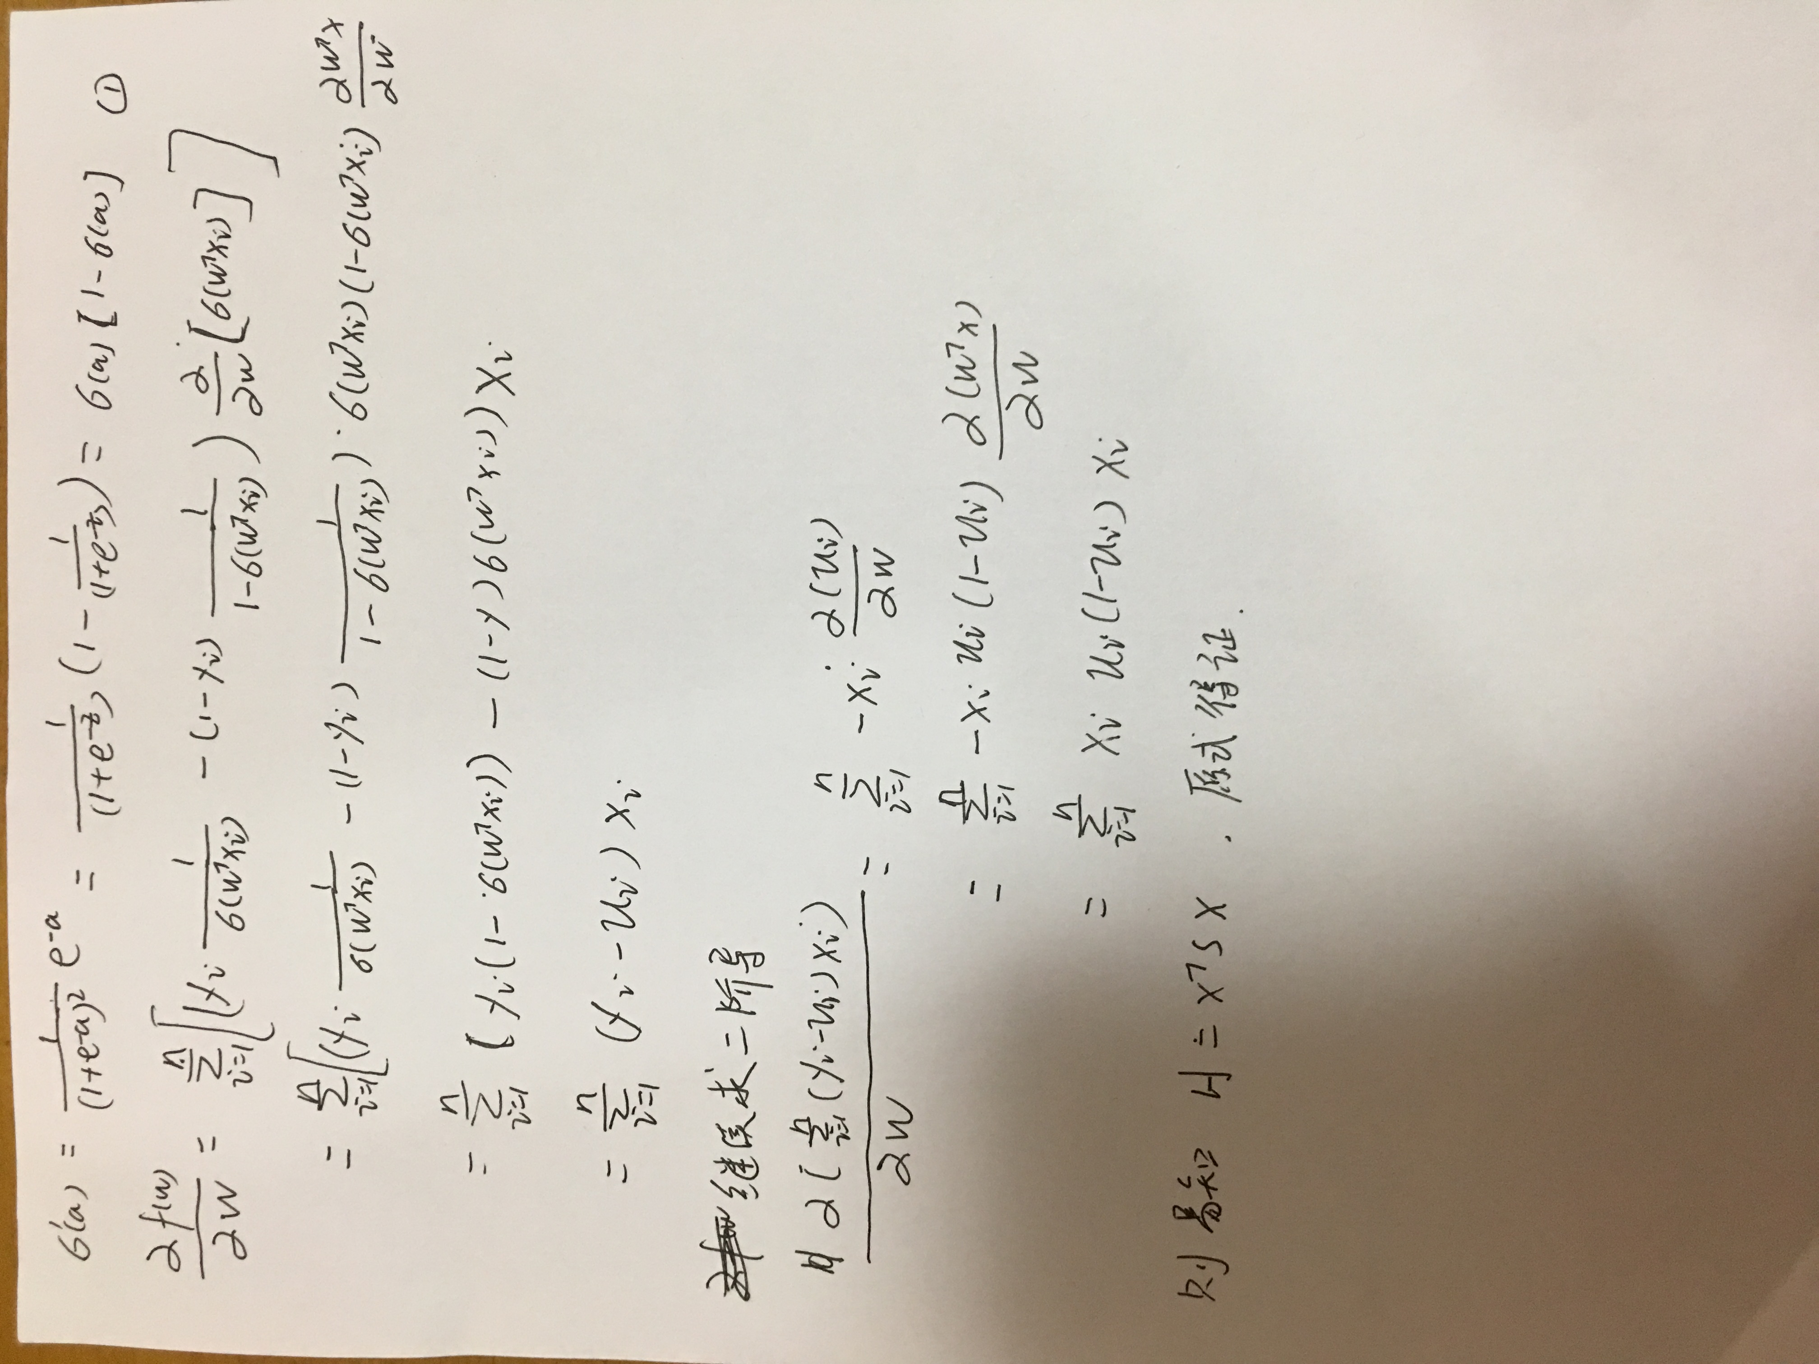

2. Linear Regression (5 points)

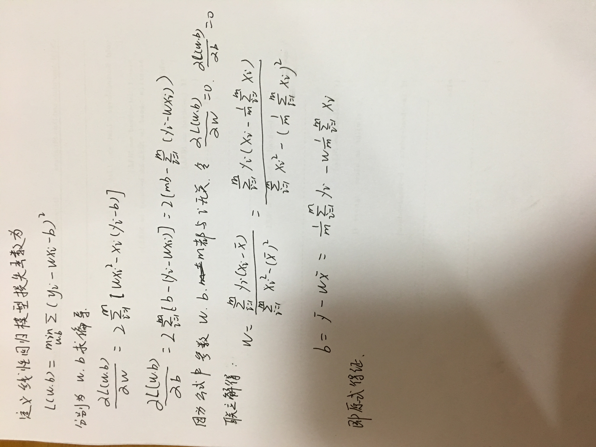

3. Gradient descent for fitting GMM (15 points)

(1)Show that the gradient of the log-likelihood wrt μk is

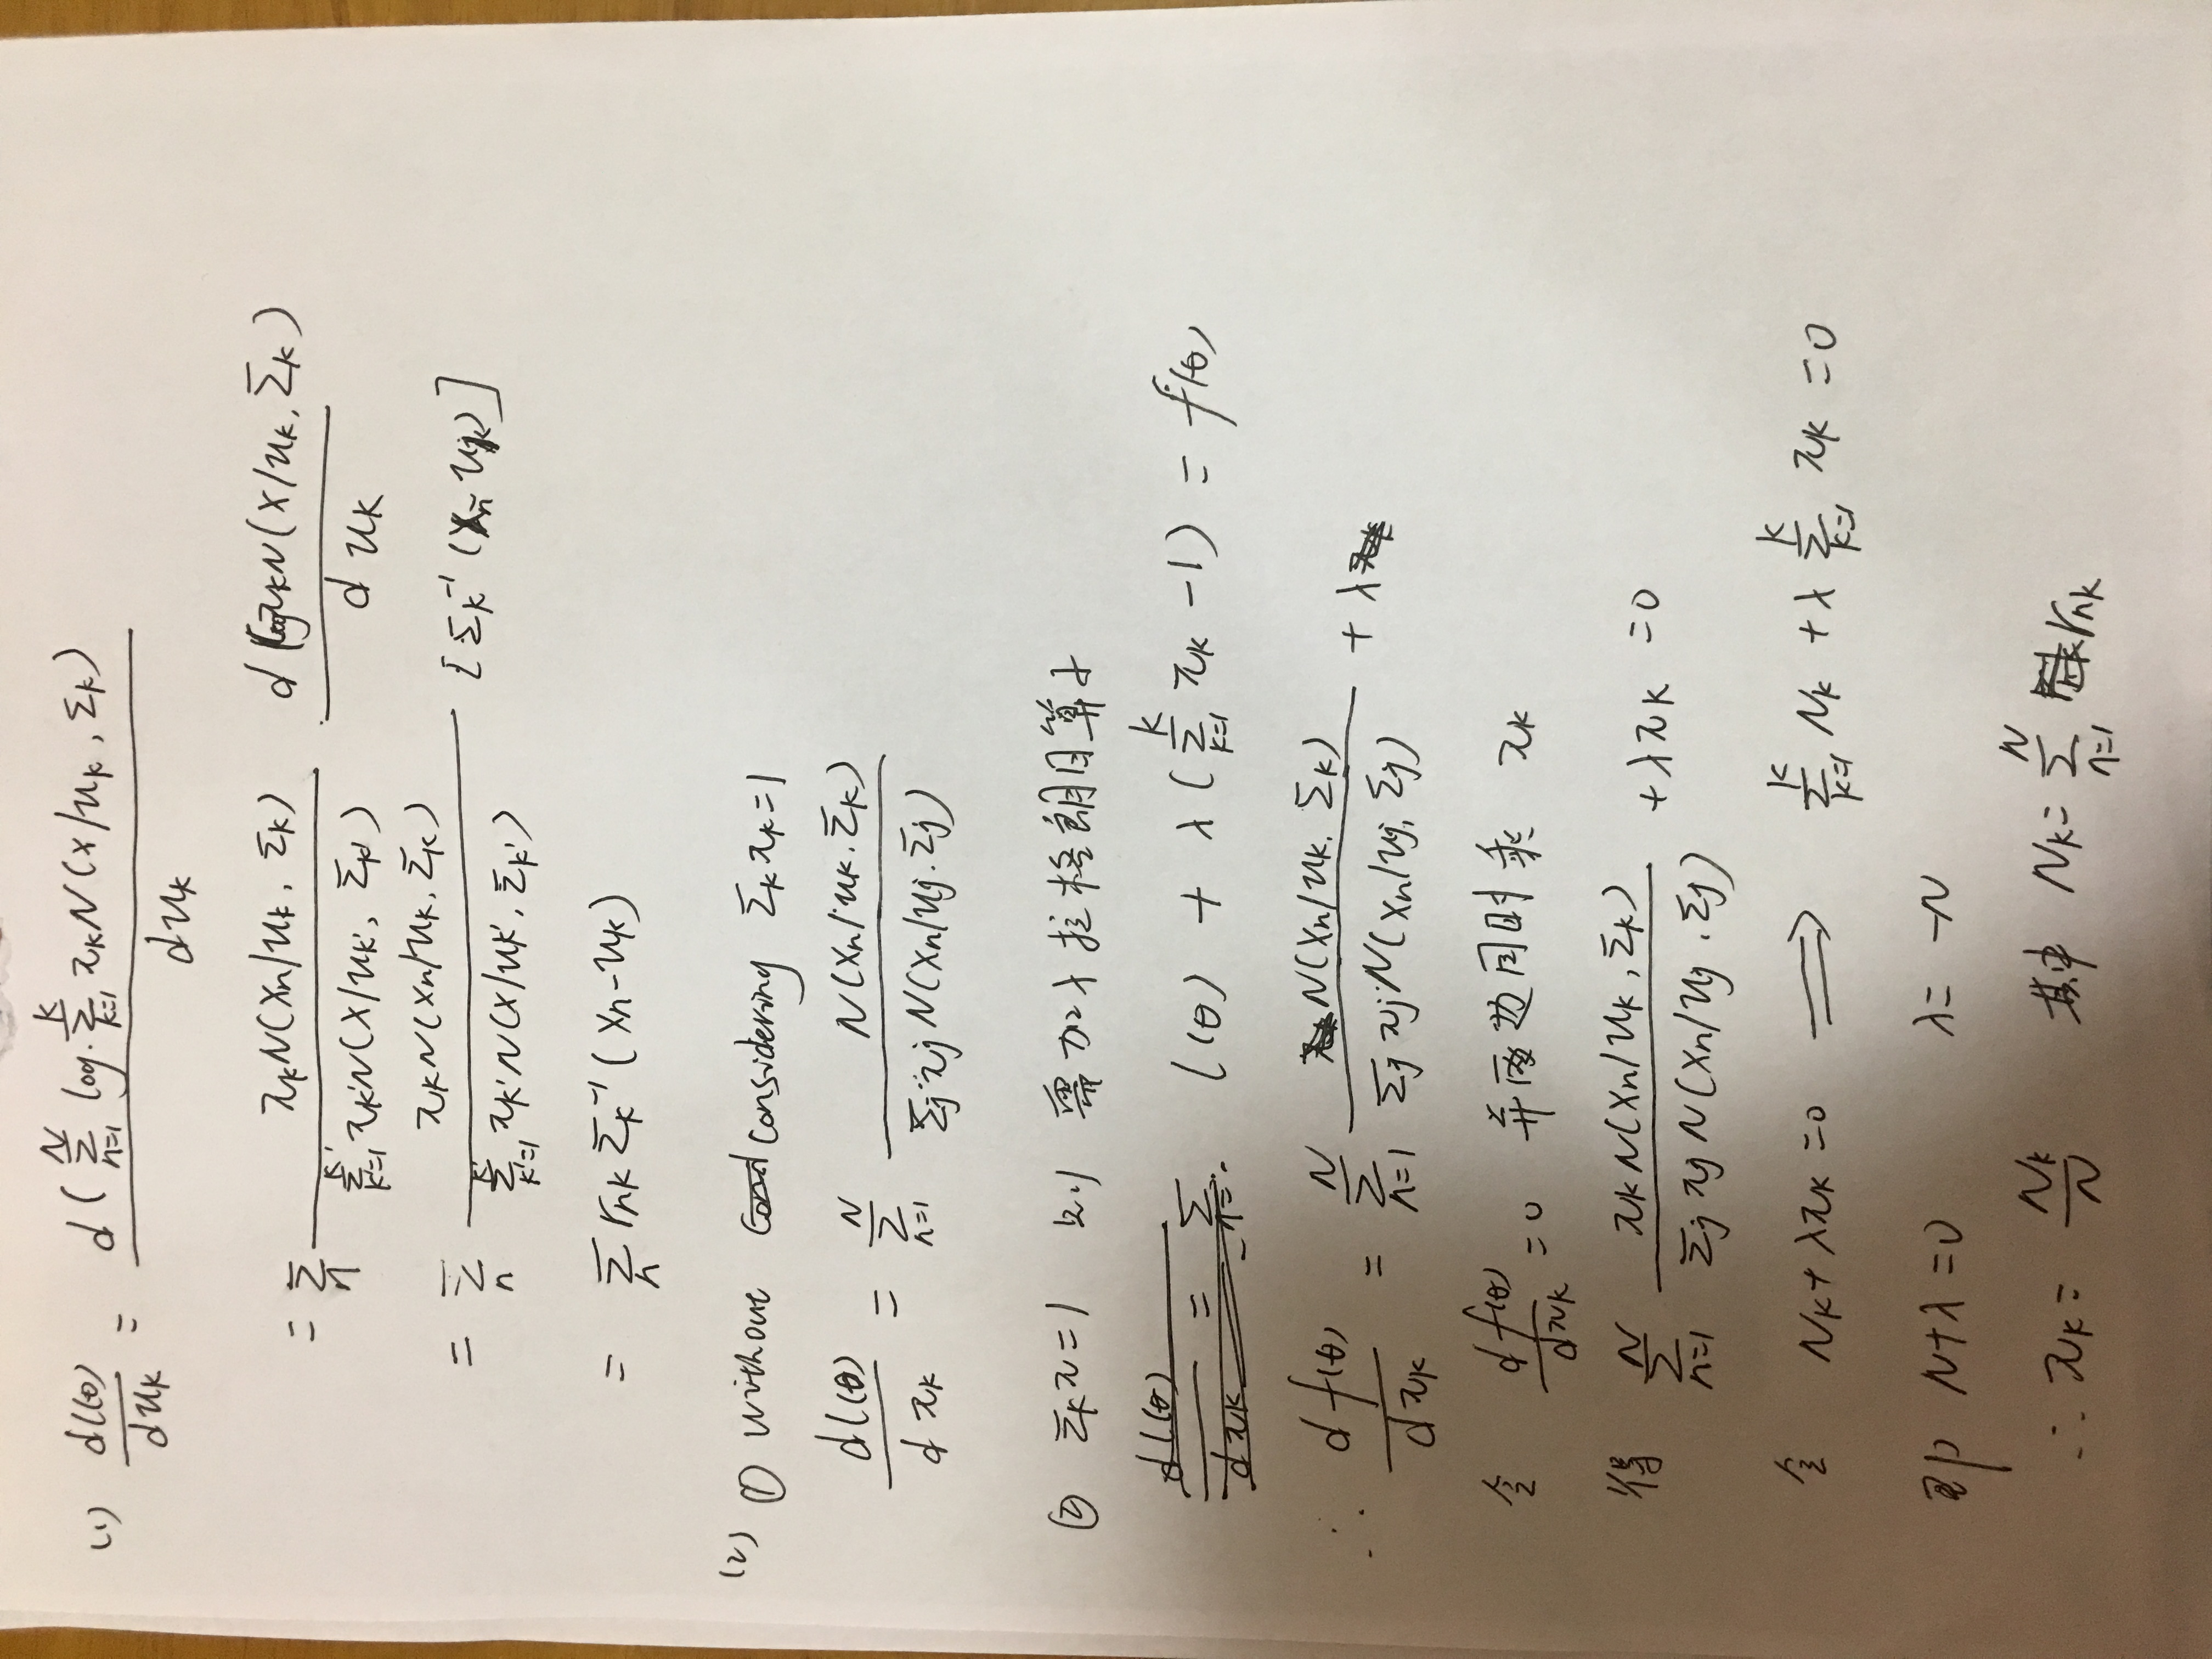

(2)Derive the gradient of the log-likelihood wrt πk without considering any constraint on πk. (bonus: with constraint)



(3)Derive the gradient of the log-likelihood wrt Σk without considering any constraint on Σk. (bonus: with constraint Σk be a symmetric positive definite matrix.)

